BSCS – 2018-2022
Shakeel Abbas Khan

EDUCATION & QUALIFICATION
University of Sargodha 2018-2022
BSCS
CGPA 3.49

Abdul Razzaq Fazia College Mianwali 2017
FSC (Pre Eng)
Subjects: Mathematics, Physics, Chemistry

Govt. High School Ghundi Mianwali 2015
Matriculation (Science)

PROJECTS
Research Project
Web Based Application (Express Service Station) using procedural approach, Audi Car Project.
Android Based Application (Sport Base App)
Object Oriented Analysis and Design
Design document of Service Station System
Database Systems
Library Management System
Design and Analysis of Algorithms
Graph Coloring
Probability and Statistics
Survey document on “Service Station a source of entertainment or time waste”

ACTIVITIES, HONORS, & AWARDS
Member, Event Management Society- University of Sargodha 2018-2022

SKILLS & TOOLS
Tools: Unreal Engine 4, Blender 3d, Android studio, Visual Studio,
SQL Server Management Studio
Microsoft Office, Coral, Photoshop,
Microsoft Visual, Eclipse, NetBeans, SPS, MS Visio Pro, Font Lab
Skills: Android Development (certified), .Net Development (Certified), Web
Development (HTML 5), Java Development.
Languages: C#, C, C++, JAVA, PHP, JAVASCRIPT, HTML

INTERESTS
Reading, playing pc games, volunteering in university events, farming and construction.


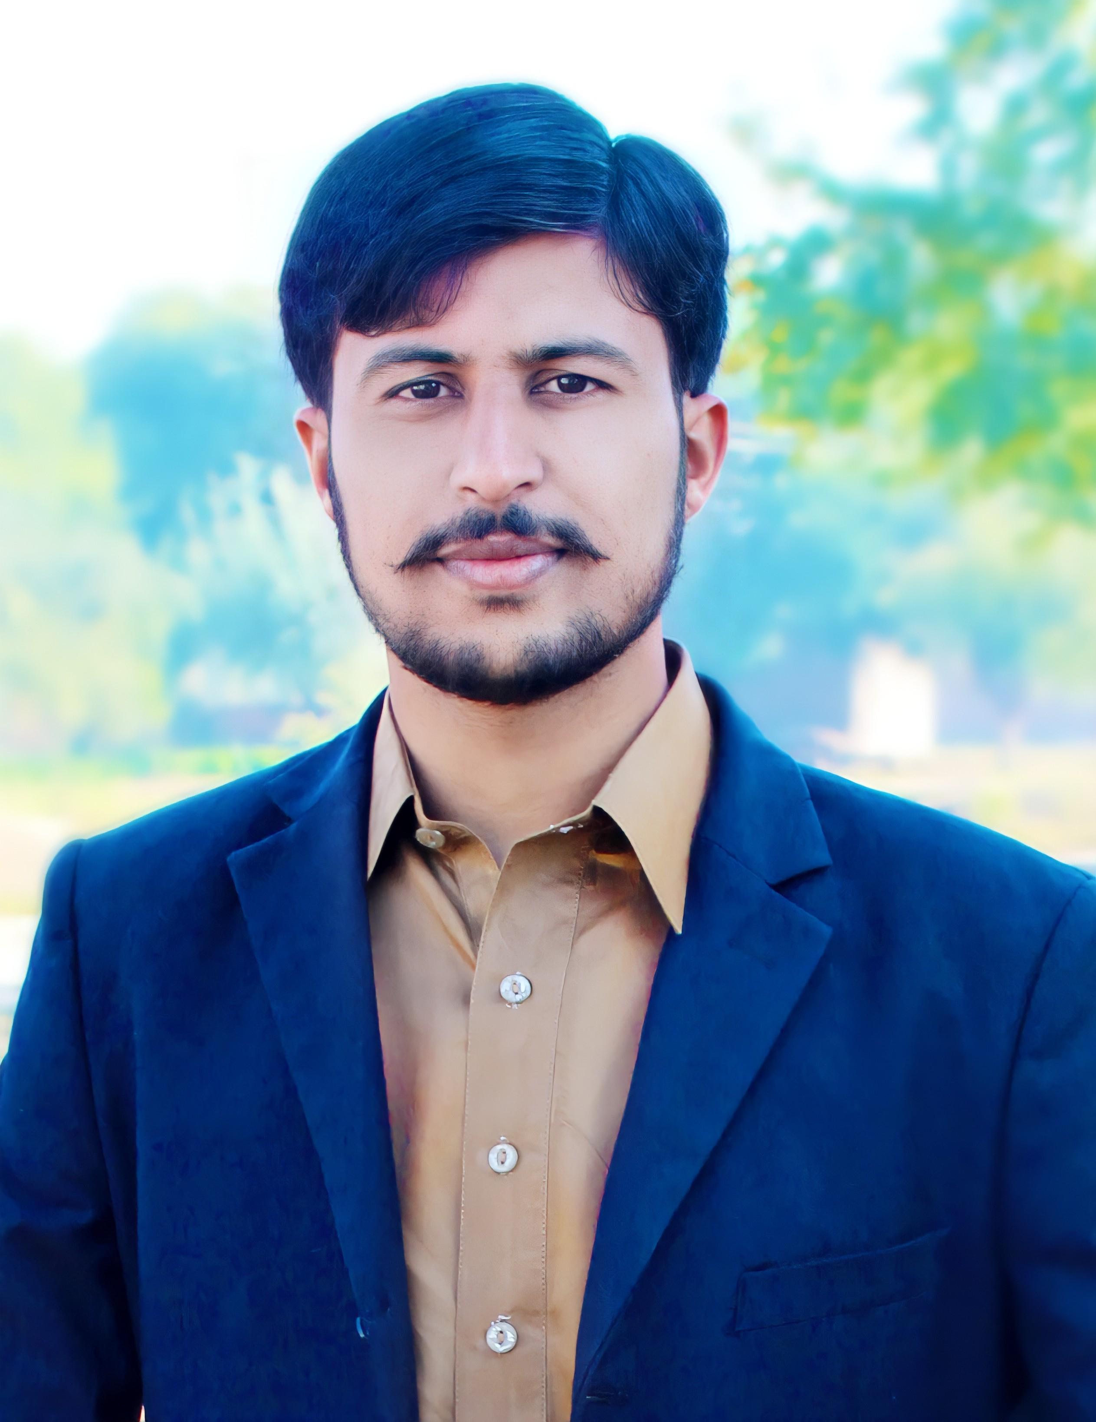Date of Birth 06/09/1999
Business Address CS & IT Department
University of Sargodha University Road, Sargodha, Pakistan Tel: +923180698530
Cell: 03000698530
Email: shakeelabbaskhan4455@gmail.com

